Goudhurst Village Hall
The Plain, Goudhurst, Kent TN17 1AT
Charity no: Charity no: 1193854
Bookings Officer: gphbookings@outlook.com
Secretary: gphtreasurer@outlook.com

GOUDHURST VILLAGE HALL
INSTRUCTIONS FOR HIRERS

Thank you for booking Goudhurst Village Hall for your event.
We hope you have an enjoyable and successful event!

The Instructions for Hirers document is important and contains the details you need to know in respect of your booking. If, having read the Instructions, you have any questions, please do not hesitate to contact the Booking Officer via email:- gphbookings@outlook.com (weekdays 10am – 5pm).

LETTING AGREEMENT
Please complete and return one copy of the Letting Agreement to the Treasurer c/o Chestnuts, Beresford Road, Goudhurst, Kent TN17 1DN, together with the Hiring fee and any deposit requested (which can be paid by cheque or bank transfer). Please note, booking periods must include preparation and clear-up time. You must not enter the hall or remain in the Hall outside the times you have booked.

DAMAGE DEPOSIT
The deposit is intended to cover the cost of any damage or breakages, or any extra cleaning costs if the Hall is left in a messy condition. Please leave the Hall as tidy as you found it - the deposit will be returned (or your deposit cheque destroyed if applicable) after the event. If paying by cheque, please write two separate cheques, one for the hiring fee and one (undated) for the deposit. Cheques should be made payable to” Goudhurst Village Hall.” Please see Damage Deposit below.

HALL KEY
The key to the Hall will be available for collection from the key press at the entrance and the details for obtaining it will be advised prior to the event. The key must be returned to the key press immediately after use as it may be required by another user – unless an alternAte arrangement has been agreed in advance by the Booking Officer

FIRE EXITS
Below is a plan showing the Hall layout and the Fire Exits. If you are intending to decorate the Hall for your function, it is important that you take great care not to allow access to the exits to be obstructed in any way. The plan below shows the FIRE EXITS. Please ensure these exits are kept free from obstructions (inside and out) when the hall is occupied.

HALL CENTRAL HEATING
The heating is controlled by a boost button in the cloakroom which allows for the hirer to set the heating for up to 2 hours at a time and can be reset if required

SMOKING
In compliance with the law, the whole building is a ‘NO SMOKING AREA’. This includes all rooms including the toilets.

FIRE ASSEMBLY POINT
The fire assembly point is on the green, opposite the hall, by the village pond. Hirers should familiarise themselves with its location.

OFFICIAL DOCUMENTATION
The fire assessment file and all Health & Safety details are kept next to the first aid kit in the kitchen.

FIRE EXITS
We would like to remind you of the requirement to ensure the fire exits are kept clear of all obstructions and the ‘fire exit’ signs are kept visible from anywhere in the hall. This is a legal requirement.

ALCOHOL
If alcohol is to be sold on the premises, a licence issued by The Licensing Partnership, P.O. Box 182, Sevenoaks TN13 1GP must be obtained. (Contact Tel: 01732 227004/Email: licensing@sevenoaks.gov.uk.). This requirement applies to all users of the hall - commercial, private, charitable users, etc. If no charge is made for alcohol served in the hall then no licence is necessary.

STILETTO HEELS
The wearing of stiletto heels is causing considerable damage to the wooden floors, any steps to minimise this damage will be appreciated.

WASTE
To comply with new waste disposal regulations, please:
Put your rubbish in the appropriate green wheelie bin at the rear of the Hall. The key can be found in the kitchen area, near the back door. Small quantities of GLASS BOTTLES, CANS, and PLASTIC bottles may be placed in the small recycling box alongside the refuse containers, although we would ask hirers to please take these away with them for recycling, if possible. Thank you.

MUSIC & FINISHING TIME
To avoid any aggravation towards residents in the vicinity of the hall, please keep volumes down to a reasonable level. No music should be played after 23.45. The Hall must be cleared-up and emptied immediately after this and before midnight.

DAMAGE DEPOSIT
For events lasting more than four hours, we require a deposit of £400 which will be returned following the satisfactory return of the Hall in a clean and tidy condition, immediately after the hiring event. If preferred, an undated cheque for £400 can be deposited with us, which will be destroyed (or sent back) following satisfactory completion.

Thank you for your co-operation in helping us to keep our valuable Parish asset a safe, pleasant and enjoyable environment.

We hope that you have a successful and enjoyable event!

The Booking Officer, Goudhurst Village Hall;
Email: gphbookings@outlook.com

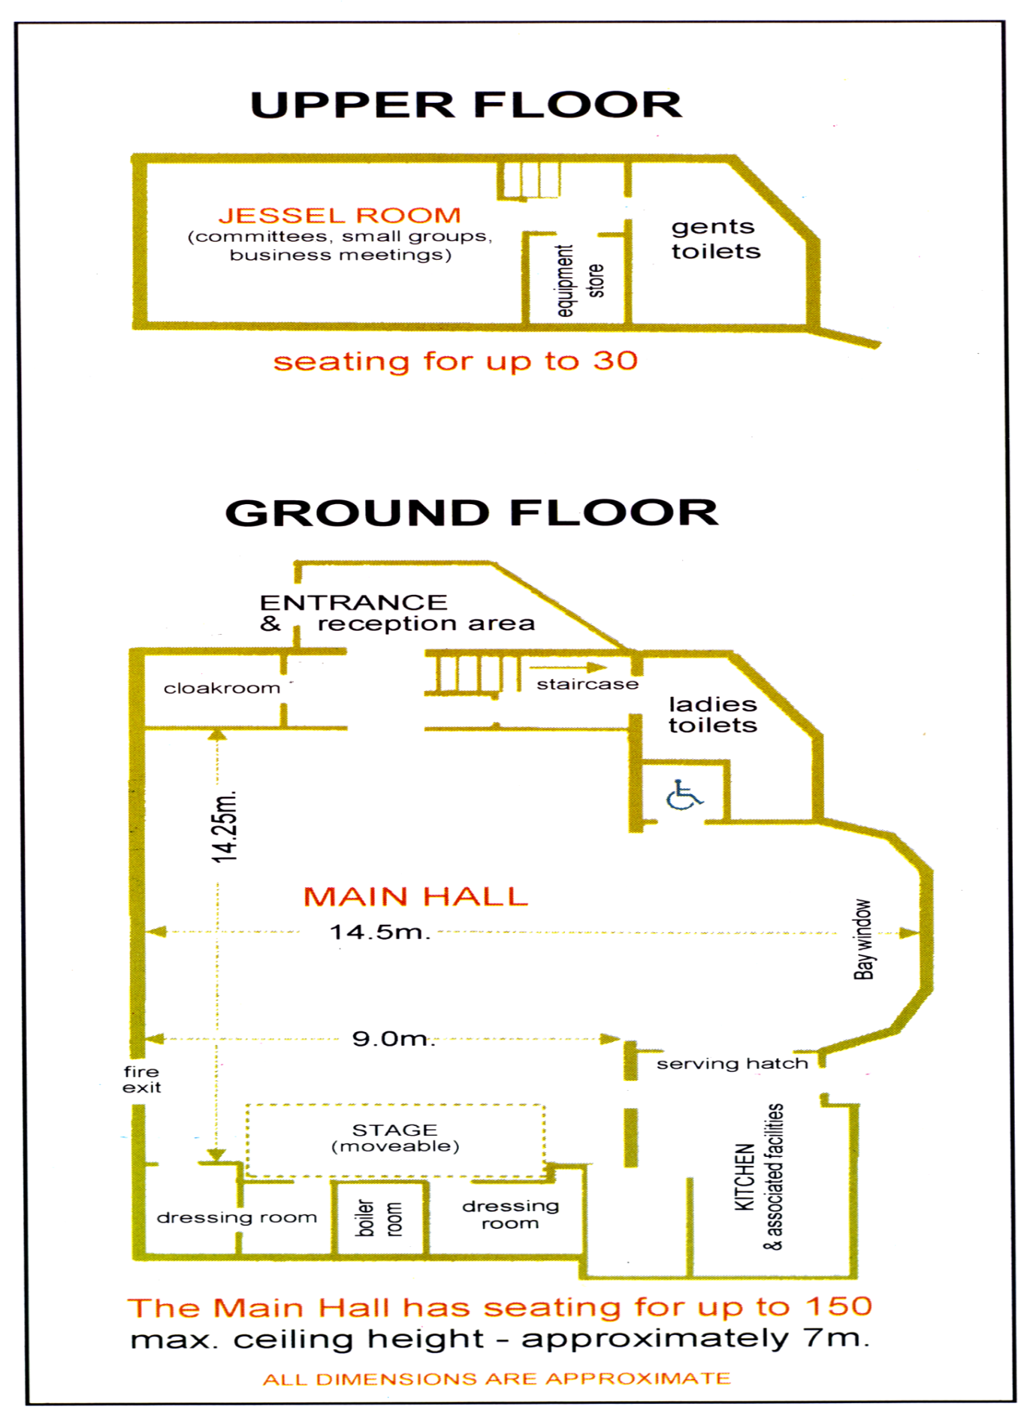
FIRE EXIT
FIRE EXIT
FIRE EXIT
FIRE EXIT

GOUDHURST VILLAGE HALL - PLAN AND FIRE EXITS

